ASSESSMENT TOOL 2: Industry Problem-Based Assignment
COURSE NAME: | ARTIFICIAL INTELLIGENCE AND EXPERT SYSTEMS | COURSE CODE: | MLA01

COURSE OUTCOME COVERED
CO 5: Construct rule-based expert systems using production rules, forward and backward chaining, and by distinguishing procedural and non-procedural paradigms across development stages.(BTL 3)
Assessment Tool Weightage: 40%
Total Marks: 100 Time: 90 Mins
No. of Questions: 1
Annexure A
Industry Problem-Based Assignment

Code of Conduct:
I Mokshitha Kilari (192525413) (Name / Reg No) certify that this submission is my original work and that I have adhered to the guidelines specified for this assessment.
I understand that any violation of academic integrity rules will result in disciplinary action.
Signature of the student: MOKSHITHAKILARI
Criterion | Weightage | Marks Obtained
1. Problem Analysis and Domain Understanding | 10%
2. Knowledge Acquisition and Knowledge Representation | 10%
3. Production Rule / Knowledge Base Design | 15%
4. Prolog Implementation and Programming | 15%
5. Forward Chaining Implementation and Demonstration | 10%
6. Backward Chaining Implementation and Demonstration | 10%
7. Procedural and Non-Procedural Paradigm Analysis | 10%
8. Unification, Backtracking and Inference Accuracy | 10%
9. Testing, Results and System Demonstration | 5%
10. Documentation, GitHub Repository and Technical Presentation | 5%
Total | 100%

Signature of the Faculty Total Marks Awarded

ANSWER ANY ONE OF THE FOLLOWING

S.No. | Industry Domain | Real-World Problem Statement
1 | Automobile Industry | A vehicle service center receives customer complaints such as engine overheating, difficulty starting, abnormal noise, low mileage, and warning-light activation. Develop a Prolog-based expert system that identifies probable vehicle faults and recommends appropriate diagnostic actions using production rules and logical inference.
2 | Healthcare | A hospital wants to assist preliminary diagnosis by analyzing symptoms such as fever, cough, breathing difficulty, body pain, and fatigue. Develop a rule-based diagnostic system that identifies possible conditions and explains the reasoning behind its conclusions using Prolog.
3 | Banking | A bank needs an automated loan pre-screening system that evaluates customer income, credit score, employment status, existing loans, and repayment history. Develop a Prolog-based decision-support system that determines loan eligibility and provides reasons for the decision.
4 | Cybersecurity | A Security Operations Center receives events such as repeated failed logins, unusual login locations, privilege escalation, suspicious file access, and abnormal network traffic. Develop an expert system that identifies possible security threats and recommends appropriate actions.
5 | Manufacturing | A manufacturing plant experiences unexpected machine failures. Operators provide observations such as abnormal vibration, excessive temperature, unusual noise, pressure changes, and reduced production speed. Develop a machine-fault diagnosis expert system that identifies probable faults and suggests maintenance actions.
6 | Agriculture | Farmers observe symptoms such as yellow leaves, spots, wilting, poor growth, and pest infestation. Develop a crop-disease advisory expert system that identifies possible diseases based on crop, soil, weather, and visible symptoms and recommends suitable actions.
7 | Telecommunications | A telecom provider receives complaints about slow internet, frequent call drops, poor signal strength, and network unavailability. Develop an expert troubleshooting system that identifies probable network problems and recommends troubleshooting steps.
8 | E-Commerce | An online retailer wants to recommend products based on customer preferences, purchase history, budget, product category, and previous interactions. Develop a rule-based recommendation system that generates personalized recommendations and explains why each product was recommended.
9 | Power & Energy | A power distribution company monitors voltage, current, frequency, temperature, and load conditions. Develop an expert system for fault diagnosis that identifies possible overload, voltage instability, equipment failure, or abnormal operating conditions and recommends corrective actions.
10 | Human Resources | An organization wants to identify suitable training programs for employees based on job role, technical skills, performance, experience, and competency gaps. Develop a rule-based employee training recommendation system that recommends appropriate training and explains the reasoning.

Structure of the Report:

S.No. | Report Section | Expected Content
1 | Title, Abstract & Introduction | Project title, brief abstract, industry background, problem context, and importance of the selected problem.
2 | Problem Statement & Objectives | Clearly define the real-world industry problem, inputs, expected outputs, stakeholders, and specific objectives.
3 | Domain Analysis & Knowledge Acquisition | Identify entities, facts, conditions, decisions, and explain how domain knowledge was collected from reliable sources.
4 | Knowledge Representation & Production Rules | Represent domain knowledge using Prolog facts, predicates, and production rules.
5 | Expert System Architecture | Provide and explain the architecture showing the user, knowledge base, inference engine, and output/explanation module.
6 | Inference Mechanism & Algorithms | Explain and demonstrate forward chaining, backward chaining, unification, and backtracking with suitable algorithms/pseudocode.
7 | Prolog Implementation | Describe the SWI-Prolog implementation, important predicates/rules, queries, and provide the GitHub repository link.
8 | Test Cases & Results | Provide minimum 5 industry-based test cases, queries, expected outputs, actual outputs, and inference traces.
9 | Analysis, Limitations & Future Enhancements | Analyze system effectiveness and reasoning accuracy; discuss limitations and propose future improvements.
10 | Conclusion & References | Summarize the developed expert system, major findings, industry relevance, and provide properly formatted references.

1. Title, Abstract & Introduction
Project Title: SOC Threat Diagnosis Expert System Using Prolog
Abstract: This project develops a defensive rule-based expert system for a Security Operations Center (SOC). It receives structured security-event observations such as repeated failed logins, unusual login locations, privilege escalation, suspicious file access, and abnormal network traffic. Production rules transform those observations into explainable threat classifications and recommended response actions. The prototype is implemented in SWI-Prolog and demonstrates both forward chaining and backward chaining, together with unification and backtracking.
Industry background: SOC teams continuously analyze alerts and must prioritize events quickly. A small expert system can provide a transparent first-level decision-support layer: it does not replace analysts, but it makes explicit, repeatable rule-based reasoning available for common alert patterns.
The assessment scenario explicitly asks for an expert system that identifies possible security threats and recommends appropriate actions from the listed SOC events. fileciteturn1file0L56-L59

2. Problem Statement & Objectives
Problem statement: A SOC receives multiple event indicators but needs a consistent method to combine them into meaningful threat hypotheses and response priorities. The proposed system maps event observations to threat categories and defensive actions using a Prolog knowledge base.
Stakeholders: SOC analysts, incident responders, security administrators, system owners, and management.
Inputs: repeated failed logins, unusual login location, privilege escalation, suspicious file access, and abnormal network traffic.
Expected outputs: credential attack, account compromise, unauthorized access, network intrusion, high-priority incident, and corresponding defensive actions such as MFA reset, account containment, endpoint isolation, log preservation, and SOC-lead escalation.
- Represent cybersecurity knowledge using facts, predicates and production rules.
- Implement a working Prolog knowledge base with explainable inference.
- Demonstrate forward and backward chaining using realistic SOC events.
- Demonstrate unification and backtracking in Prolog.
- Evaluate the rule base with at least five industry-based test cases.

3. Domain Analysis & Knowledge Acquisition
The domain model is deliberately limited to defensive alert triage. Knowledge was organized from the assessment's specified SOC observations and cross-checked against established incident-response and adversary-behavior references. NIST guidance emphasizes detecting, analyzing, prioritizing and handling incidents, while MITRE ATT&CK documents abuse of valid accounts as a security-relevant behavior that can support initial access, persistence, privilege escalation or defense evasion. citeturn0search37turn0search12
Entities: security event, user/account, endpoint, network activity, threat hypothesis, severity/priority, and response action.
Facts: event indicators supplied by the SOC. Relationships: combinations of indicators increase confidence in a threat hypothesis. Decisions: classify the event and recommend a defensive next action.
Observed fact | Meaning in the model | Possible implication
Repeated failed logins | Multiple authentication failures | Credential attack
Unusual login location | Authentication from an unexpected location | Possible account compromise
Privilege escalation | Unexpected increase in privileges | Account compromise / elevated access
Suspicious file access | Unusual access to protected files | Unauthorized access / intrusion
Abnormal network traffic | Traffic deviates from expected behavior | Network intrusion

4. Knowledge Representation & Production Rules
The knowledge base uses Prolog facts and predicates. Production rules are represented declaratively as rules whose bodies express the conditions and whose heads express the derived threat or action. The design separates observation predicates, threat rules, and response rules, which improves traceability.
Rule | IF condition | THEN conclusion
R1 | failed_logins AND unusual_location | credential_attack
R2 | unusual_location AND privilege_escalation | account_compromise
R3 | suspicious_file_access AND unusual_location | unauthorized_access
R4 | abnormal_network_traffic AND suspicious_file_access | network_intrusion
R5 | account_compromise AND network_intrusion | high_priority_incident
R6 | credential_attack | mfa_reset
R7 | account_compromise | contain_account
R8 | network_intrusion | isolate_endpoint
R9 | unauthorized_access | preserve_logs
R10 | high_priority_incident | escalate_to_soc_lead
The rule structure is consistent with the assessment requirement to represent domain knowledge through Prolog facts, predicates and production rules. fileciteturn1file0L107-L110

5. Expert System Architecture
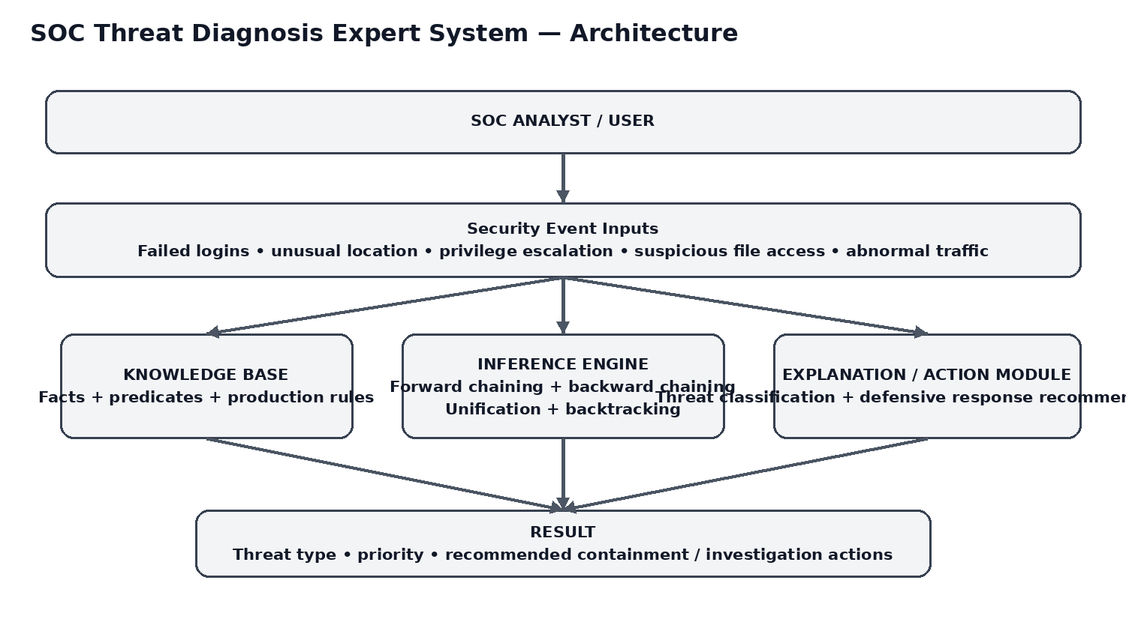
Figure 1: SOC expert-system architecture.
- User/SOC analyst supplies structured event indicators.
- Knowledge base stores facts and production rules.
- Inference engine applies forward or backward reasoning.
- Explanation/action module returns threat hypotheses and defensive recommendations.
- Results are reviewed by the human analyst before operational action.

6. Inference Mechanism & Algorithms

6.1 Forward chaining
Forward chaining is data-driven. The engine starts from known event facts, derives observation predicates, repeatedly applies rules whose premises are known, and stops when a round adds no new conclusion.
forward_chain :-
retractall(known(_)),
assert_initial_facts,
forward_round,
findall(X, known(X), Raw),
sort(Raw, Conclusions),
forall(member(C, Conclusions), format(' -> ~w~n',[C])).

Forward trace for incident_001
- Initial facts: all five indicators are yes.
- Derive repeated_failed_logins, unusual_login_location, privilege_escalation, suspicious_file_access and abnormal_network_traffic.
- R1 → credential_attack.
- R2 → account_compromise.
- R3 → unauthorized_access.
- R4 → network_intrusion.
- R5 → high_priority_incident.
- R6–R10 → five corresponding defensive actions.
- No new fact remains, so the engine terminates.

6.2 Backward chaining
Backward chaining is goal-driven. For the goal high_priority_incident(incident_001), Prolog looks for a rule that concludes the goal and then recursively proves its prerequisites. The proof requires account_compromise and network_intrusion; those require unusual location + privilege escalation and abnormal traffic + suspicious file access respectively.

6.3 Unification and backtracking
Unification binds variables to matching terms. In threat(high_priority_incident(ID)), the variable ID unifies with incident_001 when the goal is evaluated against the event facts. Backtracking allows Prolog to search alternative matching rules or return additional solutions for queries such as threat(X) and action(X).

7. Prolog Implementation
The complete implementation is supplied as SOC_Threat_Diagnosis_Expert_System.pl. It contains the sample event, observation predicates, ten production rules, an explicit recursive forward-chaining engine, a backward-chaining demonstration, and explanation queries.
% SOC Threat Diagnosis Expert System
% Defensive, rule-based cybersecurity decision-support prototype.
% Demonstrates facts, production rules, forward chaining,
% backward chaining, unification and backtracking.

:- dynamic known/1.

% ----------- Sample security event -----------
% failed_logins, unusual_location, privilege_escalation,
% suspicious_file_access, abnormal_network_traffic
event(incident_001, yes, yes, yes, yes, yes).

% ----------- Observation predicates -----------
repeated_failed_logins(ID) :- event(ID, yes, _, _, _, _).
unusual_login_location(ID) :- event(ID, _, yes, _, _, _).
privilege_escalation(ID) :- event(ID, _, _, yes, _, _).
suspicious_file_access(ID) :- event(ID, _, _, _, yes, _).
abnormal_network_traffic(ID) :- event(ID, _, _, _, _, yes).

% ----------- Production rules -----------
threat(credential_attack(ID)) :-
repeated_failed_logins(ID),
unusual_login_location(ID).

threat(account_compromise(ID)) :-
unusual_login_location(ID),
privilege_escalation(ID).

threat(unauthorized_access(ID)) :-
suspicious_file_access(ID),
unusual_login_location(ID).

threat(network_intrusion(ID)) :-
abnormal_network_traffic(ID),
suspicious_file_access(ID).

threat(high_priority_incident(ID)) :-
threat(account_compromise(ID)),
threat(network_intrusion(ID)).

action(mfa_reset(ID)) :-
threat(credential_attack(ID)).

action(contain_account(ID)) :-
threat(account_compromise(ID)).

action(isolate_endpoint(ID)) :-
threat(network_intrusion(ID)).

action(preserve_logs(ID)) :-
threat(unauthorized_access(ID)).

action(escalate_to_soc_lead(ID)) :-
threat(high_priority_incident(ID)).

% ----------- Forward chaining -----------
forward_chain :-
retractall(known(_)),
assert_initial_facts,
forward_round,
findall(X, known(X), Raw),
sort(Raw, Conclusions),
writeln('FORWARD CHAINING RESULTS:'),
forall(member(C, Conclusions), format(' -> ~w~n', [C])).

assert_initial_facts :-
event(ID, F, L, P, S, N),
assertz(known(event(ID,F,L,P,S,N))),
(F == yes -> assertz(known(repeated_failed_logins(ID))) ; true),
(L == yes -> assertz(known(unusual_login_location(ID))) ; true),
(P == yes -> assertz(known(privilege_escalation(ID))) ; true),
(S == yes -> assertz(known(suspicious_file_access(ID))) ; true),
(N == yes -> assertz(known(abnormal_network_traffic(ID))) ; true).

forward_round :-
derive_new_facts(New),
( New = [] -> true
; add_new_facts(New),
forward_round
).

derive_new_facts(New) :-
findall(F, forward_rule(F), Candidates),
sort(Candidates, Unique),
findall(F, (member(F,Unique), \+ known(F)), New).

forward_rule(credential_attack(ID)) :-
known(repeated_failed_logins(ID)),
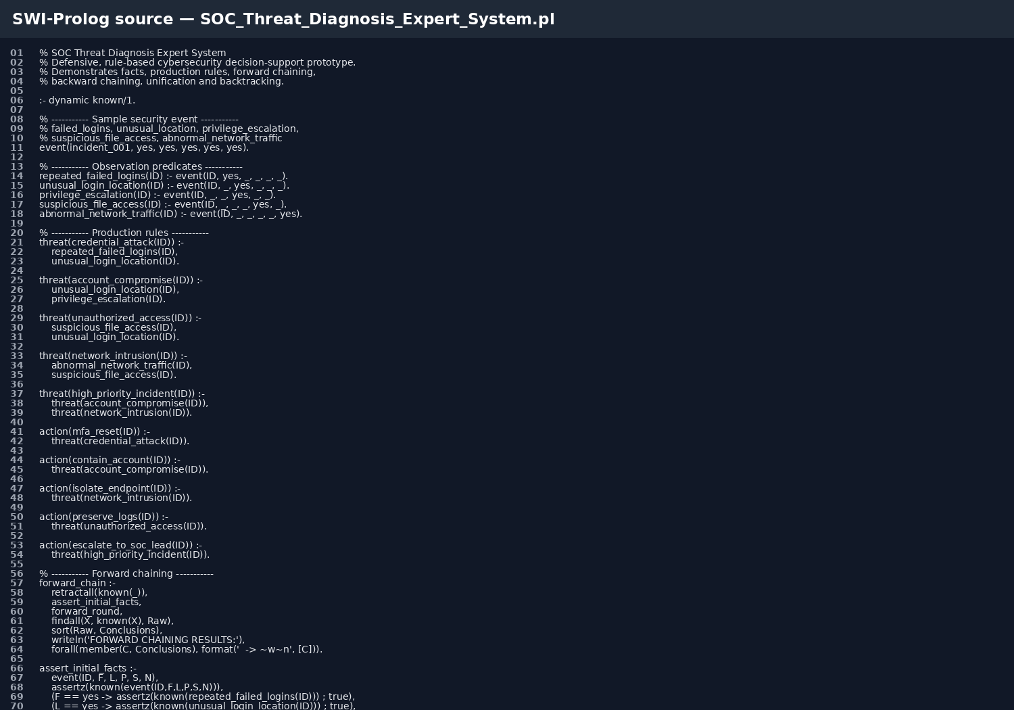
Figure 2: Prolog source screenshot.
Suggested SWI-Prolog queries: show_assessment. forward_chain. backward_diagnosis. threat(X). action(X).
GitHub repository: create a public repository named SOC-Threat-Diagnosis-Expert-System and upload the .pl file, README, screenshots, test cases and this report. The assessment explicitly expects the implementation section to provide the GitHub repository link. fileciteturn1file0L121-L123

8. Test Cases & Results
The assessment requires a minimum of five industry-based test cases containing queries, expected outputs, actual outputs and inference traces. fileciteturn1file0L125-L127
Case | Input | Query | Expected | Actual | Result | Trace
TC1 | All five indicators = yes | threat(X) | Five threat conclusions including high_priority_incident | Five expected conclusions | PASS | R1–R5
TC2 | Failed logins=yes; unusual location=yes; other indicators=no | threat(X) | credential_attack only | credential_attack only | PASS | R1
TC3 | Unusual location=yes; privilege escalation=yes; others=no | threat(X) | account_compromise only | account_compromise only | PASS | R2
TC4 | Suspicious file access=yes; unusual location=yes; others=no | threat(X) | unauthorized_access only | unauthorized_access only | PASS | R3
TC5 | Abnormal network traffic=yes; suspicious file access=yes; others=no | threat(X) | network_intrusion only | network_intrusion only | PASS | R4
TC6 | All indicators=no | threat(X) | No threat conclusion | No threat conclusion | PASS | No rule fires
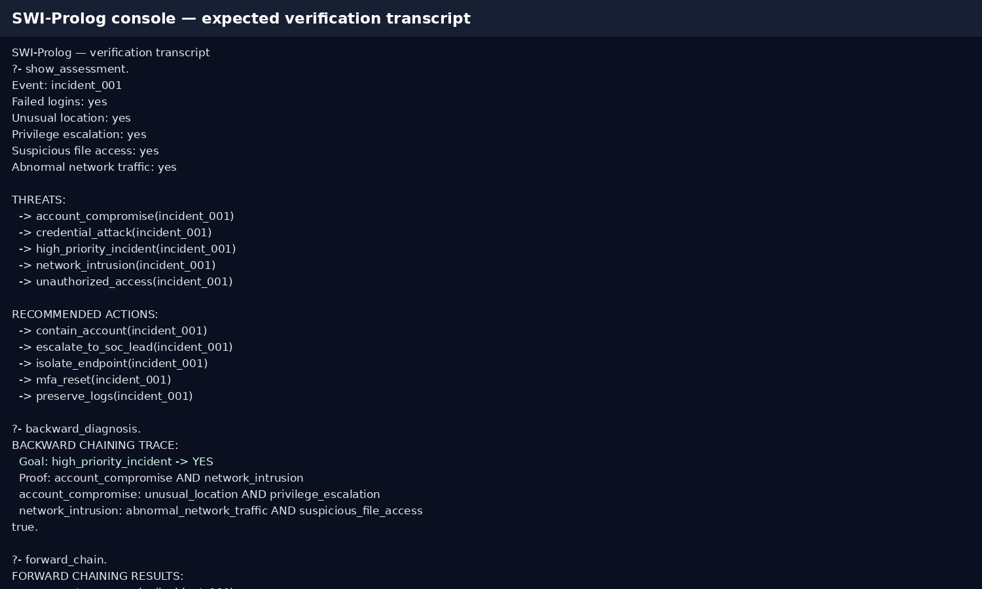
Figure 3: Documentation-ready SWI-Prolog verification transcript for the sample case.
Execution-evidence note: the image is labelled as a verification transcript because SWI-Prolog is not installed in the document-generation environment. For final submission, run the supplied .pl file in SWI-Prolog and replace the image with a live terminal screenshot if faculty verification requires it.

9. Analysis, Limitations & Future Enhancements

Results analysis
- Reasoning accuracy: each conclusion is supported by an explicit rule and its required premises.
- Consistency: the same event facts produce the same conclusions under the deterministic rule base.
- Rule coverage: the five supplied event indicators are covered by observation predicates and multiple combinations are tested.
- Explainability: the rule chain can be displayed instead of returning a black-box score.
- Industry usefulness: the prototype can support first-level SOC triage, especially when analysts need a quick, auditable rationale.

Limitations
- Fixed rules cannot capture every real-world attack pattern.
- The prototype does not ingest live SIEM/EDR logs.
- The model uses binary indicators rather than event frequency, timestamps, asset criticality or confidence scores.
- A rule-based conclusion is decision support, not proof that an attack actually occurred.
- Operational actions should be validated by authorized security personnel and organizational procedures.

Future enhancements
- Connect to a SIEM or structured log source.
- Add asset criticality, time windows and event frequency.
- Map rules to a larger MITRE ATT&CK knowledge base.
- Add confidence/priority scoring and richer explanations.
- Add a web dashboard and persistent incident history.
- Add rule-versioning and analyst feedback so the knowledge base can be maintained safely.

10. Conclusion & References
The SOC Threat Diagnosis Expert System demonstrates how a cybersecurity industry problem can be represented as a transparent Prolog knowledge base. Security-event observations are transformed into threat hypotheses and defensive recommendations through production rules. Forward chaining demonstrates data-driven alert expansion, while backward chaining demonstrates goal-driven diagnosis. Unification and backtracking provide flexible Prolog inference. The test cases show that the rule base can distinguish isolated indicators from combined high-priority patterns.
The approach is aligned with incident-response practice because effective response requires rapid detection, analysis, prioritization and handling of incidents. citeturn0search37turn0search0

References
- NIST, Computer Security Incident Handling Guide, Special Publication 800-61 Rev. 2. NIST. https://www.nist.gov/publications/computer-security-incident-handling-guide
- MITRE ATT&CK, Valid Accounts (T1078), Enterprise technique. https://attack.mitre.org/techniques/T1078/
- SIMATS Engineering, Assessment Tool 2: Industry Problem-Based Assignment, Course MLA01, CO5.
- SWI-Prolog Documentation, Prolog language and execution model.

EVALUATION RUBRICS:

Criterion | Weightage (%) | Excellent | Good | Average | Poor
1. Industry Problem Analysis and Understanding | 10% | 9–10% – Clearly identifies a relevant real-world industry problem, stakeholders, constraints, inputs, and expected decisions. | 7–8% – Good understanding with minor omissions. | 5–6% – Basic understanding with limited analysis. | 0–4% – Problem is unclear, inappropriate, or poorly analyzed.
2. Domain Knowledge and Knowledge Acquisition | 10% | 9–10% – Acquires comprehensive and reliable domain knowledge and identifies relevant facts, entities, and relationships. | 7–8% – Relevant knowledge is acquired with minor gaps. | 5–6% – Basic domain knowledge with limited sources. | 0–4% – Insufficient, unreliable, or inappropriate domain knowledge.
3. Knowledge Representation and Production Rules | 15% | 13–15% – Develops a complete, consistent, and well-structured Prolog knowledge base with appropriate facts, predicates, and production rules. | 10–12% – Well-designed knowledge base with minor omissions or inconsistencies. | 7–9% – Basic knowledge base with several missing or unclear rules. | 0–6% – Incomplete, inconsistent, or inappropriate knowledge representation.
4. Forward and Backward Chaining | 15% | 13–15% – Correctly implements and clearly demonstrates both forward and backward chaining with appropriate industry scenarios and reasoning traces. | 10–12% – Both mechanisms are demonstrated with minor limitations. | 7–9% – Basic implementation with incomplete demonstration. | 0–6% – Chaining mechanisms are missing or incorrectly implemented.
5. Prolog Implementation and Inference | 15% | 13–15% – Effectively uses Prolog facts, rules, predicates, unification, backtracking, and inference to generate accurate conclusions. | 10–12% – Functional implementation with minor technical issues. | 7–9% – Basic implementation with limited use of Prolog features. | 0–6% – Implementation is incomplete, incorrect, or non-functional.
6. Industry-Based Test Cases and Results | 10% | 9–10% – Provides diverse and realistic test cases with accurate queries, outputs, and detailed inference traces. | 7–8% – Provides relevant test cases with mostly accurate results. | 5–6% – Limited test cases and basic results. | 0–4% – Insufficient or inappropriate testing.
7. Analysis and Interpretation of Results | 10% | 9–10% – Provides insightful analysis of reasoning accuracy, consistency, rule coverage, and practical industry usefulness. | 7–8% – Good analysis with minor gaps. | 5–6% – Basic analysis with limited interpretation. | 0–4% – Results are poorly analyzed or not interpreted.
8. Procedural and Non-Procedural Paradigm Understanding | 5% | 5% – Clearly explains and demonstrates the distinction between procedural and declarative/non-procedural approaches in the developed system. | 4% – Good conceptual distinction with minor gaps. | 2–3% – Basic understanding but limited application. | 0–1% – Incorrect or missing explanation.
9. Documentation, GitHub and Technical Presentation | 5% | 5% – Complete, well-organized report and GitHub repository with clear code, documentation, references, and professional presentation. | 4% – Good documentation and repository with minor issues. | 2–3% – Basic documentation with some missing components. | 0–1% – Poor documentation or missing GitHub repository.
10. Limitations, Future Enhancements and Conclusion | 5% | 5% – Clearly identifies practical limitations and proposes realistic, technically relevant future enhancements. | 4% – Identifies relevant limitations and improvements. | 2–3% – Basic discussion of limitations and future scope. | 0–1% – Discussion is missing or unrealistic.
Total | 100%

